MoodSense AI: Intelligent Customer Feedback & Sentiment Classifier
Course Project: Artificial Intelligence (AI)
Author: Ramsha Rashid (054-71892)
Date: 14 May 2026
GitHub Repository: https://github.com/ramsharashid89/MoodSense.git
Executive Summary
MoodSense AI is a lightweight, beginner-friendly artificial intelligence application designed to automatically analyze and classify the emotional tone behind customer reviews, emails, or social media comments.
By categorizing text as either Positive (happy, satisfied) or Negative (angry, frustrated), this system helps businesses monitor customer satisfaction in real-time.
Built using a classic Multinomial Naive Bayes classifier and featuring an interactive Gradio web interface, the program transforms raw text inputs into actionable emotional insights instantly. It runs smoothly on any basic computer without requiring specialized hardware.
1. Project Objectives
Our development of the MoodSense AI system is focused on four core objectives:
- High Sentiment Accuracy: Correctly identify customer emotion (minimizing false positives, such as marking a happy customer's feedback as angry) using probabilistic text analysis.
- Instant Feedback Analysis: Provide a fast, interactive web dashboard where support teams can paste reviews and see the emotional "mood score" in milliseconds.
- Modularity: Design a clean, step-by-step pipeline (Data Loader ➔ Text Vectorizer ➔ AI Classifier) that can be easily updated with larger datasets or deep learning models later.
- Ease of Use: Create an elegant, zero-code user interface using Gradio so that anyone can test and interact with the AI model.
2. System Architecture & Diagrams
The system takes raw feedback text, strips away punctuation, converts words into numerical values, and feeds those numbers to the AI brain to calculate the mood.

2.1 Visual System Flowchart
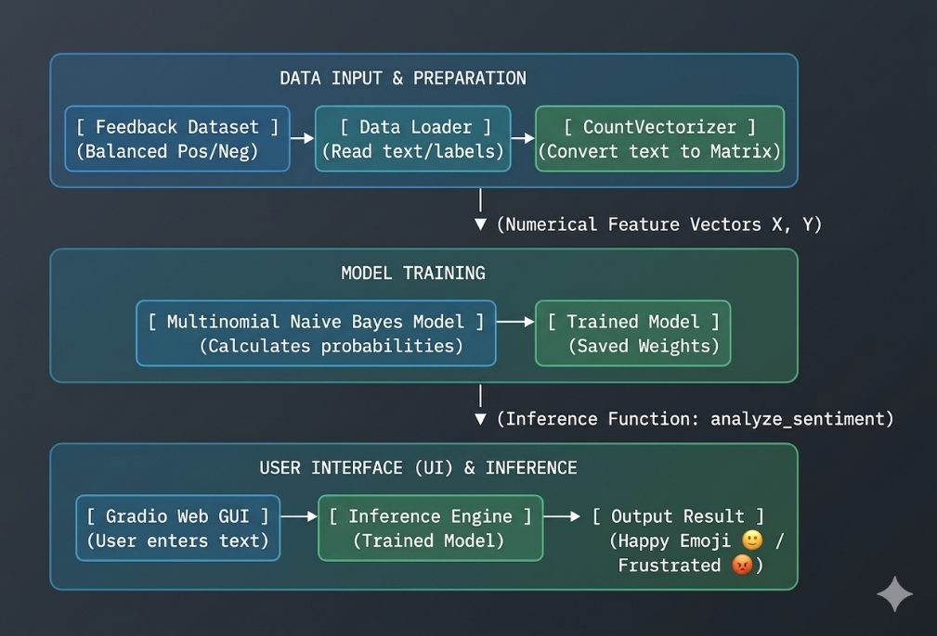

2.3 Mathematical Modeling of Naive Bayes (Made Simple)
The math behind the classifier is governed by Bayes' Theorem. The model calculates the probability that a piece of feedback $x$ belongs to a class C (where C is either Positive or Negative):
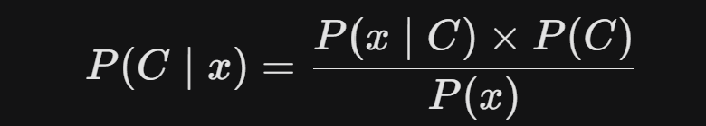
Where:
- P(C |mid x) is the Posterior Probability: The likelihood that the feedback is Positive (or Negative) given the words written in the text $x$.
- P(x |mid C)is the Likelihood: The probability of finding these exact words in reviews that we already know are Positive (or Negative).
- P(C) is the Prior Probability: The baseline probability of any review being Positive (or Negative) in our dataset.
- P(x) is the Marginal Probability: The frequency of those words across all reviews in our database.
To make things fast and simple, the "Naive" assumption treats every single word Wi in the sentence as completely independent of the other words: 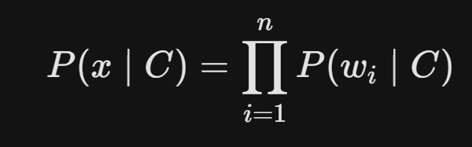
Even though words aren't actually independent in human language, this simple math works incredibly well and allows the computer to classify sentences in milliseconds!
3. Key Features
Feature Name | Description
Balanced Training | Trained on an equal number of positive and negative reviews to ensure the AI remains unbiased and fair.
Interactive GUI | A web-based interface built with Gradio, allowing non-technical managers to test reviews easily.
Keyword Association | Automatically associates words like "amazing", "perfect", and "love" with high positive sentiment, and "broken", "bad", and "slow" with negative sentiment.
Instant Presets | Includes simple pre-written positive and negative templates for one-click testing.
4. Implementation Details
This project is written in Python using clean, modular, and beginner-friendly libraries.
4.1 Feature Extraction & Model Training Code
This script loads raw reviews, processes them into numbers using CountVectorizer, and trains our Naive Bayes classifier:
import numpy as np
from sklearn.feature_extraction.text import CountVectorizer
from sklearn.naive_bayes import MultinomialNB

# 1. Sample Balanced Dataset (Reviews & Labels)
# Labels: 0 = Negative Review, 1 = Positive Review
reviews = [
"I absolutely love this product, it is amazing and fast!",
"The customer service was wonderful and very helpful.",
"This is the worst item I have ever bought, completely broken.",
"Very slow shipping and the quality is incredibly cheap and bad."
]
labels = [1, 1, 0, 0]
# 2. Convert text sentences into a bag-of-words matrix (numerical features)
vectorizer = CountVectorizer()
X = vectorizer.fit_transform(reviews)

# 3. Train the Multinomial Naive Bayes model
model = MultinomialNB()
model.fit(X, labels)

# 4. Sentiment Classifier Function
def analyze_sentiment(new_review):
# Transform input text into the same mathematical format
data = vectorizer.transform([new_review])
prediction = model.predict(data)[0]

if prediction == 1:
return "✅ POSITIVE SENTIMENT (Happy Customer)"
else:
return "❌ NEGATIVE SENTIMENT (Unsatisfied Customer)"

# Test run
print(analyze_sentiment("This product is amazing and fast!"))
4.2 Web Interface Code (Gradio Deployment)
This code takes our trained model and wraps it inside a beautiful web interface:
import gradio as gr

# Defining the mapping function for the GUI
def predict_ui(user_text):
if not user_text.strip():
return "Please enter some feedback to analyze."
return analyze_sentiment(user_text)

# Creating the Gradio Web App
app = gr.Interface(
fn=predict_ui,
inputs=gr.Textbox(lines=3, placeholder="Type or paste customer feedback here..."),
outputs=gr.Textbox(label="Mood Analysis Result"),
title="😊 MoodSense AI: Sentiment Classifier",
description="This beginner-friendly tool reads customer feedback and instantly calculates whether the sentiment is positive or negative using a Naive Bayes model.",
examples=[
["The service was wonderful and very friendly!"],
["This was a complete waste of money, very slow and broken."]
]
)

# Launch the local web server
if __name__ == "__main__":
app.launch()

